Training Plan – July-September 2018

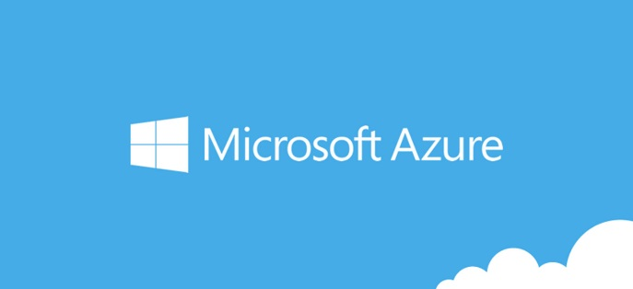

Geoffrey Owen

**Self-Learning Plan & Timeline**

**Training Course:** Azure Administrator

<https://azure.microsoft.com/en-us/training/learning-paths/azure-administrator/>

**Summary:** Become an Azure Administrator and learn how to implement, monitor, and manage the most commonly used Azure services and components.

**Time to complete learning paths:** 22h 51m + practice labs

**Coursework timeline:**

**July 16 - 19**

**Managing Infrastructure on Microsoft Azure – Getting Started**

Learn about IaaS, including storage, networking, and security. Discover how to deploy Azure virtual machines using the Azure Portal, Windows PowerShell, and the Azure Command-Line Interface, perform configuration management and enhance Azure system security.

**Microsoft Azure Virtual Machines - Getting Started**

Explore the various methods for deploying Azure VMs (Windows Server and Linux) in a highly available environment. You'll be equipped to perform configuration management and disaster recovery tasks on your new environment.

**July 20 - 25**

**Microsoft Azure Security - Getting Started**

Develop a thorough grounding of general cloud computing security principles. Explore configuring both host-level and deployment-level security, and learn the ins and outs of how to utilize Azure Security Center.

**July 20 - 25**

**Microsoft Hybrid Identity - Overview**

Learn to extend an on-premises network to the cloud and how to manage the new hybrid environment. Discover how the hybrid environment works, how to join your user directory to the Azure Active Directory, and how to offer cloud apps to your users and on-premises apps to cloud users.

**July 25 - August 1**

**Implementing Microsoft Azure Networking**

Learn to design virtual networks to support workloads with the highest security and performance. Explore configuring hybrid connectivity between on-premises environments and Azure, and how to monitor network performance to comply with service-level agreements.

**Automating Deployment and Scale of Azure IaaS Solutions**

Learn how to script, automate, and scale Azure deployments. Dive into automation technology options within Azure, learn to use PowerShell and JSON templates to define and deploy services to Azure, and how to scale resources in Azure.

**Coursework timeline:**

**Training Course:** Azure Stack Operator

<https://azure.microsoft.com/en-us/training/learning-paths/azure-stack-operator/>

**Summary:** Learn the fundamentals of Azure Stack architecture and how it is deployed, monitored, configured and updated, including how to operate the Azure Services. Discover how to enable users with the tools needed to build hybrid cloud applications.

**Time to complete learning paths:** 1h 9m + practice labs

**August 2 – August 5**

**Microsoft Azure Stack: The Big Picture**

Azure Stack makes the Hybrid Cloud model a reality and allows business to adopt Azure on-premises to meet compliance requirements. Learn the implementation, management and security practices used with Azure Stack to protect the business.

Upcoming Coursework from August 6 - 30

**Training Course:** Azure Solution Architect

<https://azure.microsoft.com/en-us/training/learning-paths/azure-solution-architect/>

**Summary:** Learn the fundamentals of Microsoft Azure solution design and architecture and how to select the best services and features.

**Time to complete learning paths:** 20h 57m + practice labs

**Upcoming - September**

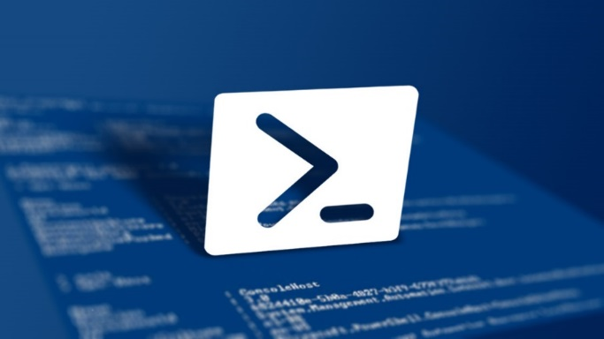

**PowerShell Training: September 1st – September 15**

Time requirements, modules and assessments for this course:

6 hours* 9 modules 9 assessment

*Excluding labs, knowledge checks and assessments.

**Getting Started with Microsoft PowerShell**

[**https://mva.microsoft.com/en-us/training-courses/getting-started-with-powershell-3-0-jump-start-8276?l=r54IrOWy_2304984382**](https://mva.microsoft.com/en-us/training-courses/getting-started-with-powershell-3-0-jump-start-8276?l=r54IrOWy_2304984382)

This Microsoft PowerShell course is designed to teach busy IT professionals, admins, and help desk personnel about how to use PowerShell to improve management capabilities, automate redundant tasks, and manage the environment in scale. Through this PowerShell tutorial, you will learn how PowerShell works and how to make PowerShell work for you from experts Jeffrey Snover, the inventor of PowerShell, and Jason Helmick, Senior Technologist at Concentrated Technology. Create a valuable experience when you take this free Microsoft PowerShell course at Microsoft Virtual Academy.

**Don't fear the shell**

This module provides an overview of PowerShell, including how to install it, manage it, and customize it. Get familiar with the shell.

**The help system**

Learn about the Help system, including updatable Help, understanding Syntax, and discoverability.

**The pipeline: getting connected & extending the shell**

In this session you will discover what the pipeline is and what it does. It will go into details on exporting/ importing CSV, exporting/ importing XML, displaying information in a GUI, cmdlets. Additionally you will learn about extending the shell and how to find and add snap-ins, modules and commands.

**Objects for the Admin**

This module reviews objects across the pipeline and how to get the information you need. You will learn about sorting and selecting objects, custom properties and filtering data, and what methods to use when no cmdlet exists.

**The pipeline: deeper**

This section reviews how the pipeline really works and the four step solution - ByValue, ByPropertyName, how to customize properties that do not match, and the Parenthetical.

**The PowerShell in the shell: remoting**

This session provides an overview of remoting and how to enable it. You will also learn how one-to-one and one-to-many remoting works.

**Getting prepared for automation**

In this module, learn about automation and PowerShell security goals, execution policy, and variables. You’ll be introduced to to fun with quotes, getting and displaying input, and other output for scripts and automation.

**Automation in scale: remoting**

In this module, learn about automation and PowerShell security goals, execution policy, and variables. You’ll be introduced to to fun with quotes, getting and displaying input, and other output for scripts and automation.

**Introducing scripting and toolmaking**

This module provides an overview of the new ISE and how to make commands repeatable, how to add parameters to your script, and how to document your script. It shows you how to turn your script into a tool for others and store your tools in a module.

**PowerShell Scripting & Automation – September 15 - 19**

**Course:** Learning PowerShell Integrated Scripting Environment

**Time:** 1h 21m

<https://www.linkedin.com/learning/learning-powershell-integrated-scripting-environment>

Learning PowerShell for Windows Server Administration

**Time:** 2h 1m

<https://www.linkedin.com/learning/learning-powershell-for-windows-server-administration>



**SQL Training: September 20st – September 28**

[**https://www.codecademy.com/catalog/subject/all/?utm_source=bing&utm_medium=cpc&utm_campaign=tm&utm_content=course_catalog_sitelink&msclkid=6e4898b539b21744f1a0c3f82b44d90a&utm_source=bing&utm_medium=cpc&utm_campaign=TM&utm_term=codecademy&utm_content=TM%20Core**](https://www.codecademy.com/catalog/subject/all/?utm_source=bing&utm_medium=cpc&utm_campaign=tm&utm_content=course_catalog_sitelink&msclkid=6e4898b539b21744f1a0c3f82b44d90a&utm_source=bing&utm_medium=cpc&utm_campaign=TM&utm_term=codecademy&utm_content=TM%20Core)

**Course:** SQL Essential Training

**Time:** 3h 27m& 12 chapter quizzes

[**https://www.linkedin.com/learning/sql-essential-training**](https://www.linkedin.com/learning/sql-essential-training)

**Summary:** Whatever a database is being used for—websites, bookkeeping, sales and inventory, or even the lowly to-do list—it's still all about the data. Completely updated for 2014, SQL Essential Training is designed to help users understand the most common language for database wrangling, SQL. Beginning with a quick start introduction for those who want to start working with data immediately, instructor Bill Weinman teaches all the major features of SQL: creating tables; defining relationships; manipulating strings, numbers, and dates; using triggers to automate actions; and working with subselects and views. He offers a solid working knowledge of the language, and shows how to retrieve and manage data efficiently. The final chapter includes a real-world example of building a simple CRUD (Create, Read, Update, and Delete) application using SQL.

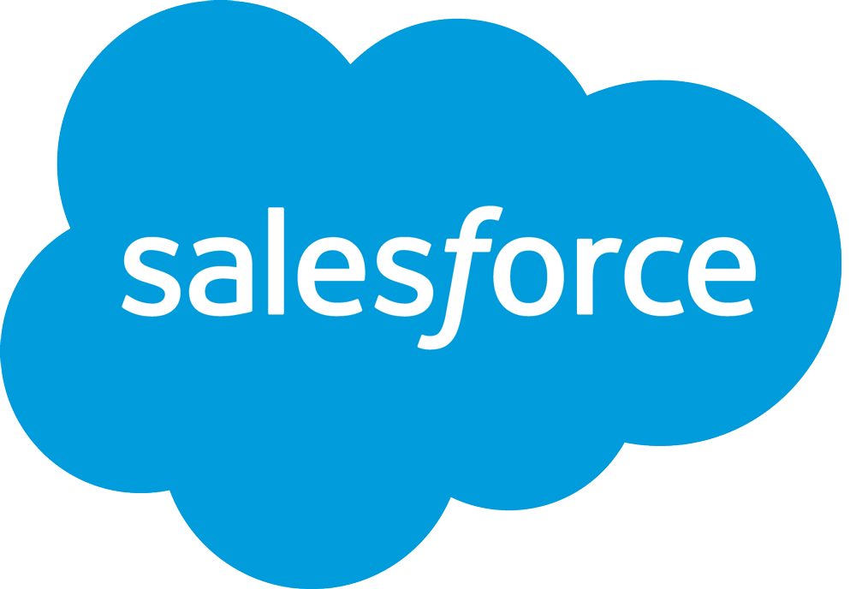

**Salesforce Training: July – January**

**Salesforce Administrator, Advanced Administrator, App Builder**

Trailhead: (<https://trailhead.salesforce.com/en/me/gowenplaces>)

This on-going training can be completed at any time and I really enjoy it. Salesforce Admin here I come!

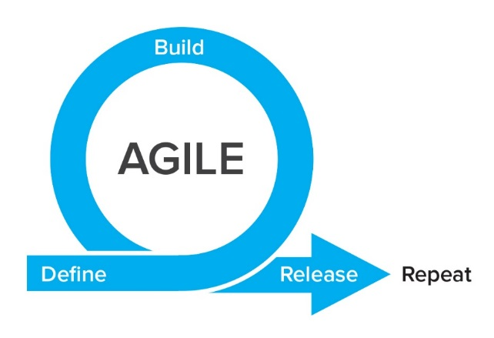

**Agile / SCRUM Training: November 1 - 20**

**Certification from SCRUMstudy.com –** Certified Scrum Developer (CSD).

Additional Agile Resources:

**Agile Project Management Principles:** <https://www.linkedin.com/learning/agile-project-management-principles>

**Agile at Work: Planning with Agile User Stories** <https://www.linkedin.com/learning/agile-at-work-planning-with-agile-user-stories>

**Cert Prep: PMI Agile Certified Practitioner (PMI-ACP)®** <https://www.linkedin.com/learning/cert-prep-pmi-agile-certified-practitioner-pmi-acp>



**Tableau Training: November 21st – December 15**

**Tableau Certification: Qualified Associate, Certified Professional**

[**https://www.tableau.com/support/certification**](https://www.tableau.com/support/certification)

[**https://www.tableau.com/learn**](https://www.tableau.com/learn)

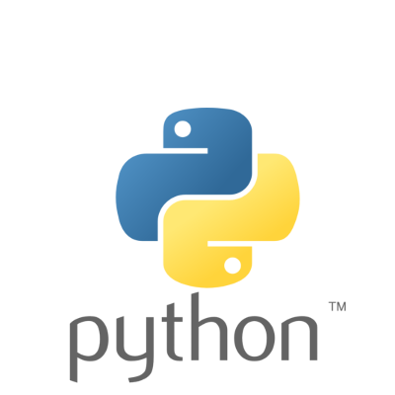

**Python & Ruby Training: December 16 – February**

[**https://www.linkedin.com/learning/search?difficultyLevel=BEGINNER&keywords=Python**](https://www.linkedin.com/learning/search?difficultyLevel=BEGINNER&keywords=Python)

[**https://www.codecademy.com/catalog/subject/all/?utm_source=bing&utm_medium=cpc&utm_campaign=tm&utm_content=course_catalog_sitelink&msclkid=6e4898b539b21744f1a0c3f82b44d90a&utm_source=bing&utm_medium=cpc&utm_campaign=TM&utm_term=codecademy&utm_content=TM%20Core**](https://www.codecademy.com/catalog/subject/all/?utm_source=bing&utm_medium=cpc&utm_campaign=tm&utm_content=course_catalog_sitelink&msclkid=6e4898b539b21744f1a0c3f82b44d90a&utm_source=bing&utm_medium=cpc&utm_campaign=TM&utm_term=codecademy&utm_content=TM%20Core)

**Course:** Ruby on Rails 5 Essential Training

[**https://www.linkedin.com/learning/ruby-on-rails-5-essential-training**](https://www.linkedin.com/learning/ruby-on-rails-5-essential-training)

**Time:** 10h 21m

**Course:** Python Essential Training

**Time:** 4h 45m

<https://www.linkedin.com/learning/python-essential-training-2/welcome>

**Summary:** Due to its power and simplicity, Python has become the scripting language of choice for many large organizations, including Google, Yahoo, and IBM. A thorough understanding of Python 3, the latest version, will help you write more efficient and effective scripts. In this course, Bill Weinman demonstrates how to use Python 3 to create well-designed scripts and maintain existing projects. This course covers the basics of the language syntax and usage, as well as advanced features such as objects, generators, and exceptions. Learn how types and values are related to objects; how to use control statements, loops, and functions; and how to work with generators and decorators. Bill also introduces the Python module system and shows examples of Python scripting at work in a real-world application.